**Assignment-Eng. Charles Kithome**

1. Consider a disease known as diabetes mellitus, which is characterized by an increase in the blood sugar level. Infectious agents may contribute to the development of the disease in early childhood, but are not the main cause of the disease. Can it be classified as communicable? Explain your reasons

Answer- Diabetes mellitus (DM) is a clinical syndrome associated with deficiency of insulin secretion or action. It is considered one of the largest emerging threats to health in the 21st century. Besides the classical complications of the disease, DM has been associated with reduced response of T cells, neutrophil function, and disorders of humoral munity. Consequently, DM increases the susceptibility to infections, both the most common ones as well as those that almost always affect only people with DM (e.g. rhinocerebral mucormycosis) No it cannot be classified as communicable, however infectious diseases are more frequent and/or serious in patients with diabetes mellitus, which potentially increases their morbimortality. The greater frequency of infections in diabetic patients is caused by the hyperglycemic environment that favors immune dysfunction (e.g., damage to the neutrophil function, depression of the antioxidant system, and humoral immunity), micro- and macro-angiopathies, neuropathy, decrease in the antibacterial activity of urine, gastrointestinal and urinary dysmotility, and greater number of medical interventions in these patients. The infections affect all organs and systems. Some of these problems are seen mostly in diabetic people, such as foot infections, malignant external otitis, rhinocerebral mucormycosis, and gangrenous cholecystitis. In addition to the increased morbidity, infectious processes may be the first manifestation of diabetes mellitus or the precipitating factors for complications inherent to the disease, such as diabetic ketoacidosis and hypoglycemia. Immunization with anti-pneumococcal and influenza vaccines is recommended to reduce hospitalizations, deaths, and medical expenses.

1. How would you classify pulmonary tuberculosis using the epidemiologic method? What is the main importance of such classification?

ANSWER

Epidemiological information on tuberculosis (TB) is required to plan control and prevention strategies and to inform service delivery systems.It is not possible to conduct a suitable program without sound evidence on epidemiology status of TB disease. Epidemiological information on TB is required to plan control and prevention strategies and to inform service delivery systems. Assessment of the epidemiological indices within a specific time period can also help planners to focus on the main problems of a community and to assess the efficacy of preventive programs.

1. Describe four or more bacterial vaccine-preventable diseases that have the same modes of transmission.

Bacterial pneumonia (infection of the lungs), caused by bacteria called Streptococcus pneumoniae and Haemophilus influenzae,

| **Disease** | **Bacterial cause (scientific name)** | **Mode of transmission** | **Symptoms** | **Prevention and control methods** |
| --- | --- | --- | --- | --- |
| **Diphtheria** | Corynebacterium diphtheriae and its toxin | Respiratory by coughing or sneezing | Sore throat, loss of appetite, and slight fever | Diphtheria vaccine, combined with two or four other vaccines against pertussis, tetanus, BCG, etc. |
| **Tetanus** | Clostridium tetani | From soil into a wound or broken skin, through direct contact | Stiffness in the jaw and neck, with stomach and muscle spasms | Tetanus vaccine for children, combined with other vaccines, or given alone for women of childbearing age |
| **Meningitis (infection of the brain or spinal cord)** | Neisseria meningitidis | Respiratory by coughing or sneezing | Fever, headache, neck stiffness, coma | Meningococcal vaccine and treatment by antibiotics |
| **Streptococcus pneumoniae** | Respiratory by coughing or sneezing | Fever, headache, neck stiffness, coma | Treatment by antibiotics; a pneumococcal conjugate vaccine (PCV) will be introduced to Ethiopia soon |  |
| **Pneumonia (infection of the lungs)** | Streptococcus pneumoniae | Respiratory by coughing or sneezing | Cough, fast breathing/difficult breathing (more details are given in Study Session 35) | Treatment by antibiotics; a pneumococcal conjugate vaccine (PCV) will be introduced to Ethiopia soon |
| **Haemophilus influenzae** | Respiratory by coughing or sneezing | Cough, fast breathing/difficult breathing (more details are given in Study Session 35) | Treatment by antibiotics; Hib is part of the pentavalent vaccine |  |

1. What are the causes and methods for preventing bacterial meningitis?

Meningitis is an inflammation of the membranes (meninges) surrounding your brain and spinal cord.and is mostly caused by a viral infection, but bacterial, parasitic and fungal infections are other causes. Some cases of meningitis improve without treatment in a few weeks. Others can be life-threatening and require emergency antibiotic treatment.

Several strains of bacteria can cause acute bacterial meningitis, most commonly

:**Streptococcus pneumoniae (pneumococcus).** This bacterium is the most common cause of bacterial meningitis in infants, young children and adults in the United States. It more commonly causes pneumonia or ear or sinus infections. A vaccine can help prevent this infection.

**Neisseria meningitidis (meningococcus).** This bacterium is another leading cause of bacterial meningitis. These bacteria commonly cause an upper respiratory infection but can cause meningococcal meningitis when they enter the bloodstream. This is a highly contagious infection that affects mainly teenagers and young adults. It may cause local epidemics in college dormitories, boarding schools and military bases. A vaccine can help prevent infection

.**Haemophilus influenzae (haemophilus).** Haemophilus influenzae type b (Hib) bacterium was once the leading cause of bacterial meningitis in children. But new Hib vaccines have greatly reduced the number of cases of this type of meningitis

.**Listeria monocytogenes (listeria).** These bacteria can be found in unpasteurized cheeses, hot dogs and lunchmeats. Pregnant women, newborns, older adults and people with weakened immune systems are most susceptible. Listeria can cross the placental barrier, and infections in late pregnancy may be fatal to the baby.Viral meningitis Viral meningitis is usually mild and often clears on its own. Most cases in the United States are caused by a group of viruses known as enteroviruses, which are most common in late summer and early fall. Viruses such as herpes simplex virus, HIV, mumps, West Nile virus and others also can cause viral meningitis.

The most effective way to prevent meningitis is to [get vaccinated against the disease](https://www.everydayhealth.com/meningitis/guide/" \l "meningitisvaccine).

The other prevention of meningitis- by not sharing items where secretions can lurk, such as drinking glasses, water bottles, straws, silverware, toothbrushes, lipsticks or lip glosses, and cigarettes. A healthy immune system can help **prevent** an infection from the viruses and **bacteria** that **cause meningitis**. Keep your immune system at its fighting best by eating healthy — including fresh fruits and vegetables, whole grains, and lean proteins

1. Explain two characteristics that illustrate how the Anopheles larvae are different from other mosquito larvae. Using illustration is advised

There are two common types of mosquitoes that lay their eggs in water: anophelines, which can be vectors of malaria, and culicines, which do not carry malaria. See figure below for detailed differences and characteristics

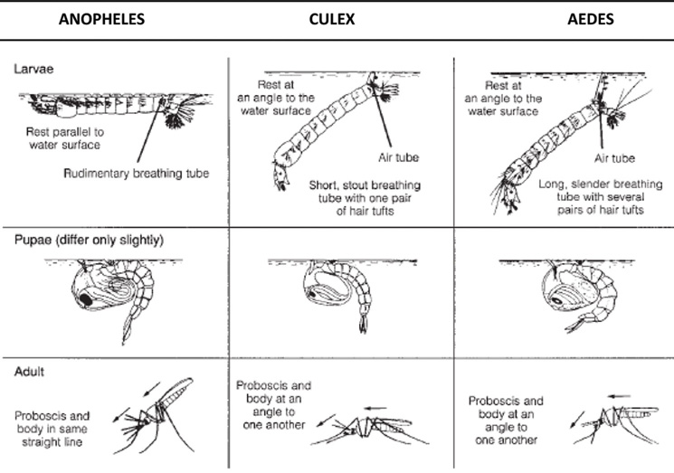

Figure 1Distinguishing features of anopheline mosquitoes (potential malaria vectors) and culicine and aedes mosquitoes (which don’t transmit malaria). (WHO, 1997; source as in Figure 9.2)

There are four stages in the mosquito life cycle, and three of them — eggs, larvae and pupae — are to be found in water.